11.69: a) The force diagram is given in Fig. 11.9.

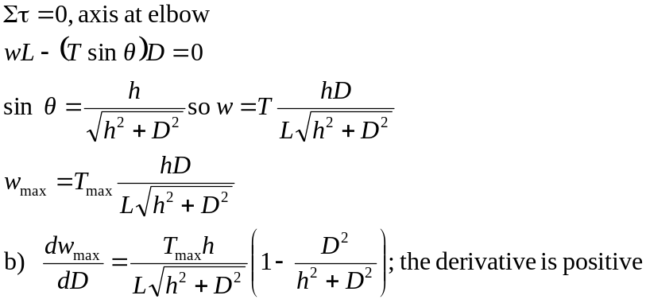
c) The result of part (b) shows that 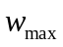increases when D increases.

